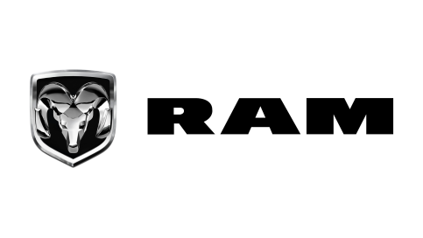


GSO Conformity Certificate CCR No. 567628
Motor Vehicles
Manufacturer: FCA US LLC
Country of Origin: CANADA, Country of Production: CANADA
To: GCC Standardization Organization (GSO)
We hereby certify that the vehicles manufactured by FCA US LLC
* Type: RAM 1500 SST Rebel X 3.0L Pick-up 4×4 4Doors
* VlN number:
* Model Year: 2025 * Produced in and after: Month 07 Year 2025
* Category: Truck
Will satisfy the G50 Technical Regulations Nos: 34:20o7, 3s:2007, 36:2005, 37:2012, 38:200s, 392005, 40:2011,42:2015, 48:1984, 51:20o7, 52:2007, 53.2007, 9611988. 9721988, 9811988, 9921988,13522007, 13622007. 29021994. 4119:1994,42o:1994,421:2005,422:200s.1040:20001041:2000,1042:2000,1053:2000,1503:2010,1598:2002,1624:2002,1677:2003,1708:2o0s,1780:2010,1781:2006,1782:2008,1783:2006,1784:2o0e.Gsolso1585:2008,GSO lSO 3537:2008, GSO 150 3538:1997, G50 ECE13H:2012,GSO ECE13H-1:2012,GSO ECE13H-2:2012,GSO ECE 13H-3:2012, GSO ECE13H-4:20l2, GSO ECE13H-S:2012,GSO ECE 13H-6:2012 and the standards in the country of origin accepted by GSO in the case that no GSO technical regulations and standards are available.
All the essential technical data are as follows:
1. Weights
a. Maximum Vehicle Weight: 3450 kg b. Curb: 2550 kg
c. Maximum Axle Weight: Front: 1750 kg Rear: 1900 kg
2. Dimensions
a. Length: 5916 mm b. Width: 2085 mm
c. Height: 1960 mm d. Wheelbase (Fl R1) 3692 mm e. Track: Front: 1740 mm Rear: 1740 mm
3. Type of chassis and body: Body-on-frame
4. Number of Passengers: 5(Including the Driver)
5.Engine: Petrol a. Cylinders: 6 b. Displacement: 2993cc c. Air intake: Twin Turbo
d. Net Engine Power: 313 kW at 5200 rpm Pollutant Limit comply with Euro 6B standards.
6. Transmission: Automatic

7. Brakes a. Service Brakes: Hydraulic b. Emergency Brakes: Combined with the service brakes
8. Fuel Economy a. Motor Vehicle Class: Light Truck b. FE (CAFE) Combined: 09.5 km/L - Poor
9. Any other information or local standards to be compiled: Also comply with the National regulations for member countries mentioned in the Annex of the list of Technical Regulations for MV 2025 MY-D3, when exporting to those countries.
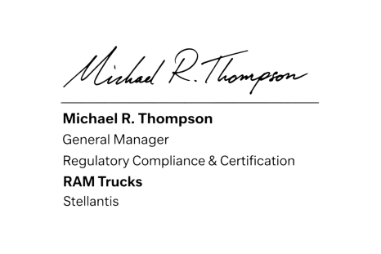
17 SEP 2025

